Changing PACSystems UDP Station Manager Password via AUP File

UDP Remote Station Manager for PACSystems Controllers

GE Intelligent Platforms has been working to provide more secure products when it comes to networking and passwords. One change that has been made is to disable the Ethernet UDP station manager port so that hackers could not exploit this once open port. For those who wish to reopen that port for use in collecting fault data and troubleshooting Ethernet problems, GE Intelligent Platforms has allowed the user to provide a non-default station manager password by way of an Advanced User Parameter file (AUP file). This is a text file that must be created with a specific name and contain specific line entries in order to modify various Ethernet parameters including the UDP Station Manager Password. Once this AUP file is associated with an Ethernet interface, the UDP station manager interface will be re-enabled for use.
The AUP file must have a name of the form:
AUP_r_s.apf
where r and s indicate the Rack and Slot location of the Ethernet Interface. (For an embedded Ethernet interface, r and s indicate the Rack and Slot location of the CPU module.)
The following example sets the station manager password to “mypassword". The target Ethernet interface in this case is in Rack 0 Slot 1. The file name is AUP_0_1.apf and contains the following two lines of text:
AUP_0_1
stpasswd = “mypassword” ; set the password to “mypassword”
Next, the user must add this file to their project so that it can be downloaded to the PACSystems controller for use by the Ethernet interface. Note that downloading this file requires the controller to be placed in stop mode, since the file is part of the configuration. Once this file is downloaded the UDP station manager port will be enabled and PACsStation Manager and PACsAnalyzer utilities can be used to collect diagnostic data from the Ethernet interface. In order to attach this file to the proper Ethernet interface, expand your hardware configuration and click on the Ethernet interface to be associated with this file and browse to the file by clicking on the “…” in the property inspector as indicated below.
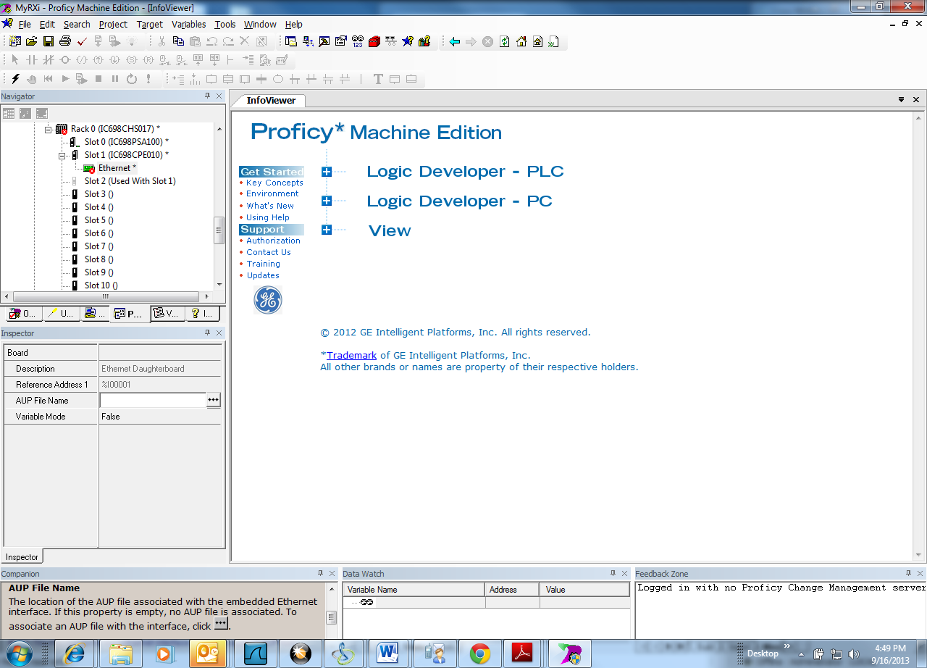

Product | Version | Module
Ethernet | All | All
RXi Controllers | All | All
RX7i Controllers | All | All

